Events in the Department year 2023

1. **Seminar on World Cancer Day on 4th February 2023**

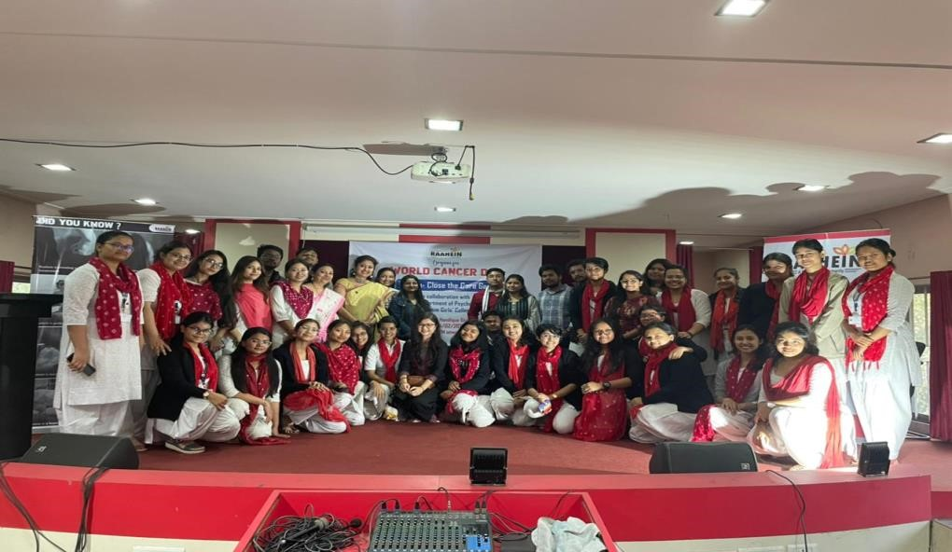

1. **College procession held on 13th Feb ,2023**

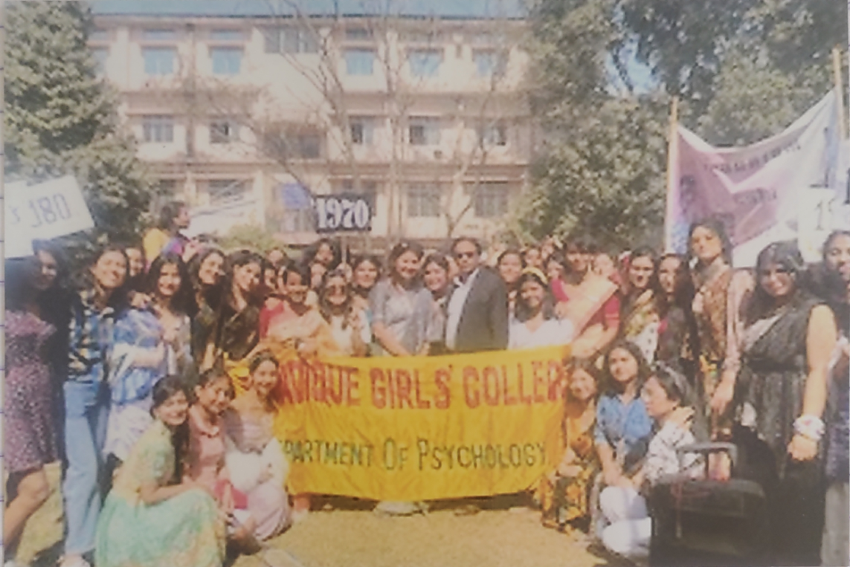

3. EVENT: Clinical Workshop and activities on 3rd and 4th of March 2023

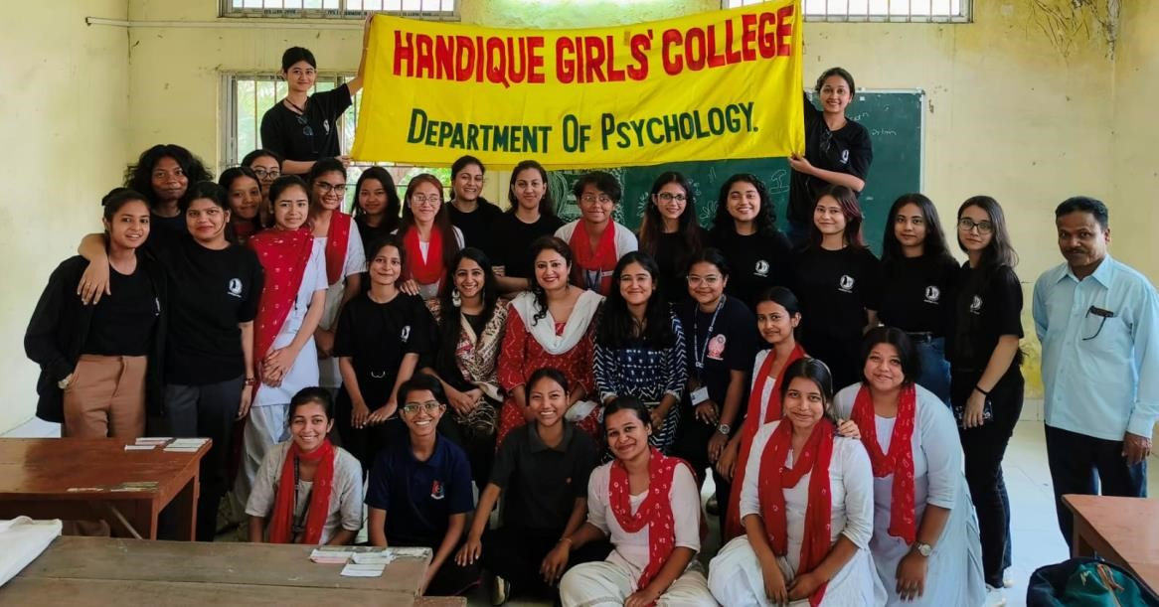

4.EVENT: Movie Show as the Celebration of International Women’s Day on 6th March ,2023

MOVIE SHOWN: Shabaash Mitthu

